**Case Study: Regenerate the soil Project (Regesoil)**

Within Nakivale, a growing number almost 36% of the population are farmers grappling with dwindling yields attributed to eroded and infertile soil. Many of these farmers resort to chemical fertilizers, unaware that such practices are disrupting ecosystems and hindering the creation of fertile soil through sustainable means.

Given their dependence on agriculture for livelihoods, it's alarming to estimate that in just five years, their current farming methods could render them unable to produce food. To counteract this, Unidos has taken the initiative to foster a deeper connection between human systems and the environment, facilitating a shift from humanitarian dependency to be self-reliant.

Through the partnership with Re-alliance ,Unidos has been able to build ,recyle food waste and produice organic and rich fertilizer that regenerate the soil to be more productive and educate farmers in different regenerative agricultural technics enabled farmers to grow more food despite small or large space ,refugees have access to.

**Key Issues:**

* Farmers in Nakivale face declining yields due to soil erosion and infertility. Current reliance on chemical fertilizers is unsustainable and could lead to food insecurity within five years.
* Lack of land to cultivate
* Farmers are still practicing traditional agriculture which makes them vulnerable to climate change as the soil keeps on degrading

**Initiatives:**

* Unidos collaborates with Re-alliance on the 'Regenerative Camps and Settlements' project to introduce sustainable farming in refugee camps,by building vermicomposting site where food waste once recycled will be transformed into organic fertilizer then apply it into the soil to be more productive ,educate more farmers about this new approach for soil regeneration.
* Focus on vermicomposting: transforming 100kg-500kg of local food waste weekly into nutrient-rich fertilizer.
* Partnership with UNHCR aims to reach 1,800 farmers by 2024 to adopt a systemic approach that prioritises complementary ecological and socioeconomic interventions to enhance regenerative agriculture practices in and around Nakivale.

Our collaboration with UNHCR ,Realliance and Lush ,has fuelled our impact and enabled us to reach thousand of refugees who have been practicing traditional agriculture which in return was not successful due to the climate change ,soil which is not fertile ,insuffient of spaces to farm etc..thus educating them has been a great way of empowering them shifting from traditional farming to regenerative farming and climate adaptation ,soil regeneration while taking care and have control on it.

The funds has enabled us to have adequate ressources to design different demonstration sites where we have built the vermicompost units and produce organic fertilizer as describe above.

Of course these demonstration sites will reflect our vision and be an inspiring place where everyone will revealed the true sense of regeneration in a hopeless place like refugee camps

and this through our ecological ,social and economical impact on the livelihood of refugees.

.

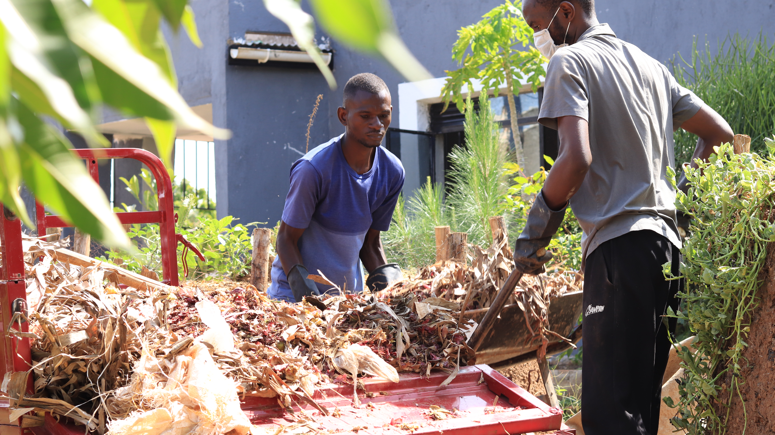

*Unidos team members collecting food waste to be decompose into an organic fertilizer*

**Impact:**

Trained 1,500+ refugees in sustainable farming techniques like soil assessment and organic composting.

* 20% of participants now produce and sell organic fertilizer.
* 30% reported increased production levels; 2% higher yield compared to chemical fertilizers.
* Soil water retention improved, with drainage rates decreasing from 10 cm/hour to 8 cm/hour.

**Additional Efforts**:

* Cultural exchange programs to foster community unity.
* Collaboration with the Ugandan Government's Office of the Prime Minister for land provision.

**Core Values:**

Focus on community resilience, sustainability, and unity rather than imposing external solutions.

**Conclusion:**

Unidos and Realliance are not just regenerating land but also fostering hope, unity, and empowerment, setting the stage for lasting change.

we want toscaling up worm production by investing in increasing the production of worms to meet the growing demand from the refugee community. This involves creating worm farms and ensuring a steady supply of high-quality worms for vermicomposting its worm castings which is a great nutrient organic fertizers to build soil health and regenerate it be more productive

Educational Programs: We will intensify our educational programs to teach refugees how to effectively utilize vermicomposting for soil regeneration. Workshops, training sessions, and practical demonstrations will be conducted to empower community members with the necessary knowledge and skills.

**Our future plan**

By creating spaces where people from different walks of life can work together, we contribute to the principle of diversity and inclusion, ensuring that the voices and perspectives of all community members are valued and heard.

As we witness the positive results of our initiatives, such as the adoption of vermicomposting, we see hope rekindled within the community. This success creates a positive feedback loop, reinforcing our commitment to addressing climate change and building resilience. It also strengthens the diversity of ideas and solutions within our community as we explore and share innovative approaches to tackling environmental challenges.

Ultimately, our holistic approach fosters greater self-sustainability within the Nakivale refugee settlement and reduces dependency on foreign aid. By upholding principles of justice, diversity, and inclusion, we not only contribute to the well-being of underserved groups but also promote a more equitable and resilient community that can face the challenges of climate change with confidence.

**what we envision to achieve in the near future**

As we are expecting our project to impact and benefit both farmers, improve the whole ecosystem ,mitigate climate change and the the shift of regenerative agricultural productivity system.

For Farmer: Increase higher yields, shift from agro-chemicals to organic ,more healthy and productive soil resient farms, shift from traditional to regenerative farming.

For the Ecosystem ,climate and regenerative agricultural system: Enhancing water retention,increasing soil biodiversity and ecosystem reparation, less soil degradation and erosion reduced ,enabling environmental resilience to both droughts and floods.

For investors and donors: Being part of our mission of contributing on the SDGs, Investing in soil regeneration and support farmers in food sovereignty ,contributing to offset emissions and decarbonizing the economy.

**Here is our regenerative business model Canvas**

